

Run #, 29 June 2013, Golf 3 (or was it 1 or 2?) Rabat.

Yes, Rabat Hash House Harriers, this is your roaming guest reporter writing. Guess who??
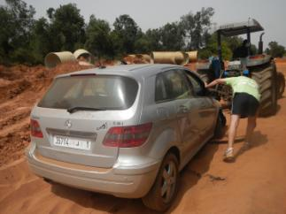
Where shall I start? Well, what can you expect when a hasher named after a natural disaster sets the hash? Exactly, a catastrophe. Look at these pictures!! Tsunami was the hare, and she was struck not by big waves of water, but big waves of sand. Her poor fellow-hare? She made him do the same and he got stock too.
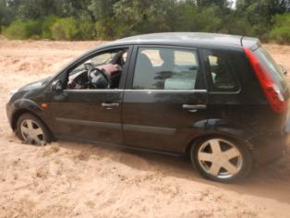
Help! I'm stuck in the sand!

So we ended up walking an improvised hash, with 40 degree heat....until Thank Allah, Buddha, Krishna and God ... the beer stop!
The bustards runners (compost, Ratatouille, Bodyguard) managed to do a live run in the heat and when they were back, the flies of the area couldn’t be more as they started licking and drinking their sweat !! A new bee from Germany, Leoné, tried to show her running skills and stamina, but after the first half, she wisely decided its no joke running with such maniacs, so she decided to walk back and safe her skills for beer drinking, and yes, she was good at it !!
During the circle, after properly punishing the hares ( for no apparent reason ), introducing returnees and new bees, Comatose offered Our GM a “ gift” from Antanaarivo Hash !! it’s a good hash tradition and Comatose still have style in keeping with tradition ! BUT, our Generous GM, who is no less traditional on hash matters, quickly and swiftly and elegantly responded by offering a GIFt to Antananarivo’s GM and all the wankers down there, including our Dear Ex GM Le Pimp !!

To me ( Comatose) it was wonderful meeting all you HARD CORE hashers again, Caligula, Body Guard, Hot Rocks, Lady Godiva, Compost, Dolly Parton and Bob the Builder and last but certainly not least Ah yeah!!!! I like to move it .. move it...
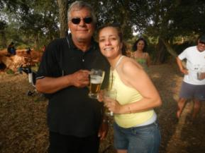
Glad the hash is still going strong! Even Genghis Khan showed up at the end (only two hours late). And nice to meet you new hashers: Tsunami, MP Free and others (give me a down-down for not remembering all the new names).

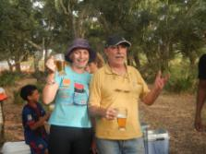
The circle was long and hot...here are some impressions.
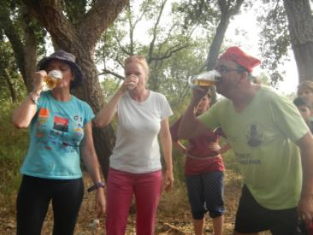
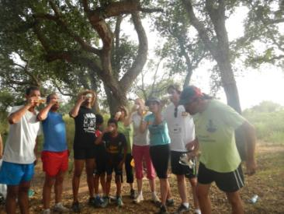
ON ON to LE PIMP!
I'm thirsty too :-)
Newbee! Do you raise your right hand and swear to tell the truth...?
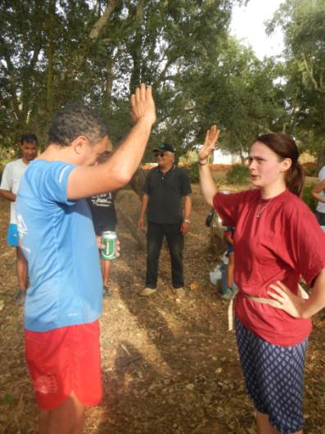
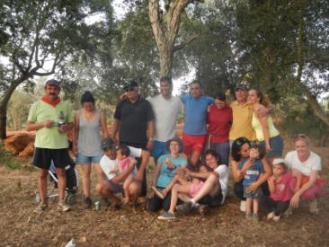
Desert Orchid & Sleeping Beauty
GROUP HUG
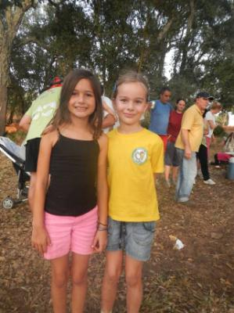
From Madagascar HHH with Love!!

Comatose and Sleeping Beauty

p.s. don't miss next year's interhash in Brussels Check it out http://www.interhash2014.com/.... REGISTER NOW!

