
^{Rabat Hash House} Harriers
Run: #1458  Date: Sat. July 6th 2013  VENUE: Barrage One  HARES: Sex and the City, MPfree | 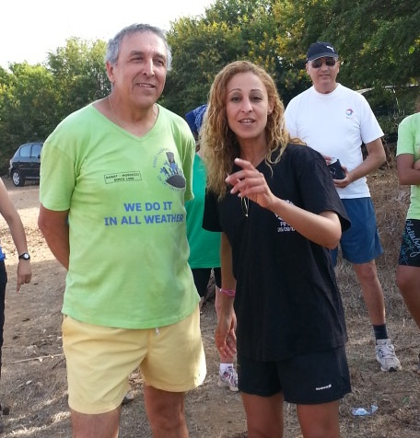

Better late than never..

This was the last run/hash before the fasting month, Ramadan, and it was a HOT day ! So, as if to punish, or to celebrate (both notions are relatives at the hash) the hares, Sex and the City and MPfree, decided to set a long trail around Barrage One.

Keeping in mind that a considerable part of our usual running/ hashing trail in this site has gone private, hares managed just well to find a new- creative trail : along the still under construction road !! Right, that way, hashers saw first hand what will become of the area when this part of the highway is done!

But it must also be said: hares did choose this trail also because workers on the construction site had put in the whole area plenty of flowers/marks! Why waste valuable commodity ( it’s Ramadan) when you get if there for free !!

Front runners B. were Compost, Ratatouille, Bodyguard and just Leoné ( who seems to prefer to run behind them to watch or admire their backs)! there was also, on and off, Mpfree and Sex the City, looking after hashers from a distance as a good shepherd would do !

Wankers, as usual, were Tsunami, Horny Parker, Wet and Wild, Bob Job, Bob the Builder (only this time), Gyros, Pink flamingo…and many more !

The GM doesn’t fit in any of the above !

Chef de cuisine was with the GM, so the above applies !
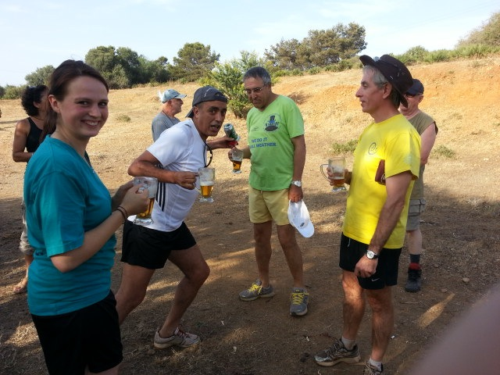
Michiko again brilliantly looked after the hash valuable, but also play the ‘ agent de liaison’ with the locals ! ( see below)

It was a long stretch of a run on the dusty field, with few round-about, until we had to do a kind of detour, just to catch up with a delighted GM walking hand in hand with Chef de Cuisine! Front runners paid necessary and due respect to the GM and run away without looking back!

And when we thought we are done as we came up a little hill, Sex and the City shouted “ no no, its not what it seems to be” !! Indeed, we were warned at the beginning! So instead of heading back to the On In that we were a stone throwing away from, we had to go left on an other long not too dusty run trail ! after sweating it all out, it was a relief to see the lake looking at us, from distance ! Compsot (dripping like a mad horse by then ) led us down the little forest toward the water ! but before doing so, he slowed down and called upon Sex and the City and just Leoné to join the front runners in order to run to the beer stop as a team ! well, we thought he’s strongly behaving as a gentleman at the hash, until we found out he was pushing them in front to charge them later as front runners !!

The beer stop was well kept and looked after by a group of wankers who, some how, managed to be there, chatting and enjoying themselves by the lake, life is not fair !! Most runners jumped into the lake and when they came out and were handed cold beer, they complained no more !

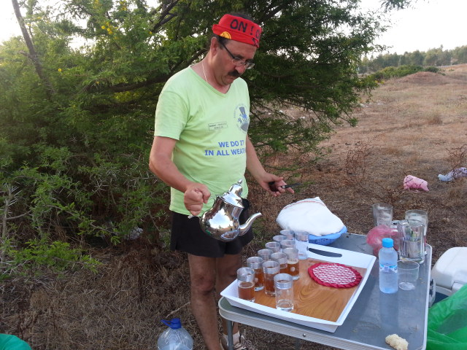
Back to the circle, the crowd has one again experienced the hospitality of the locals, for a kind woman with her son showed up with a tray of tea, along with ‘baghrir’, butter and honey!! A feast shared by all. The little one who took some softies as a return gift from the hash, came back inquiring if he can also have a beer!! Great hash potential I must say !

The circle (with all the rituals ) lasted quite long, load of beer consumed afterward, and hashers looked ready for Ramdan, or so I presumed !

ON ON!
Bodyguard
