
Rabat ^{Hash} House ^{Harriers}

Run #1459  Date : Sat. July 13th 2013  VENUE : Chez Gyros  HARES: Mother Hen, Tadpole & Gyros | 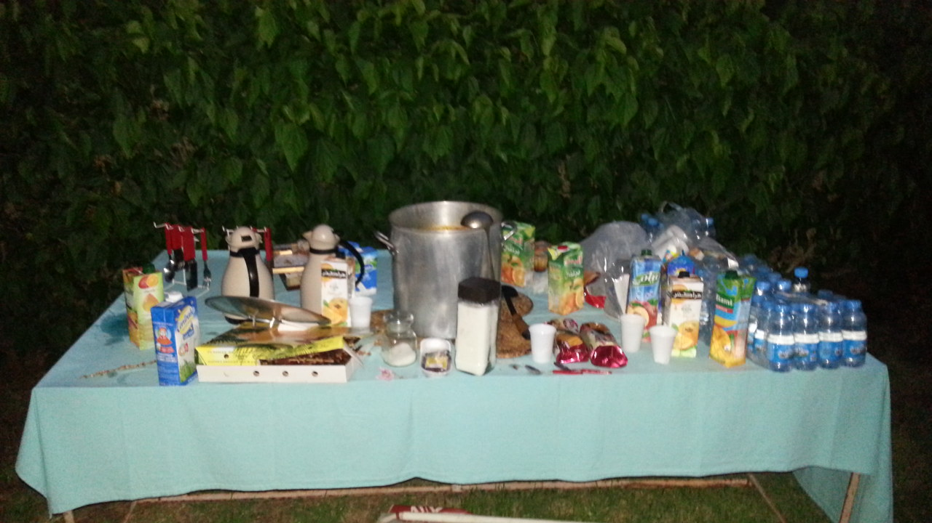

Don’t ask me when did it start? I just don’t know. Surely I came right on time to hit the trail with a pack of hashers deciding whether they run or they walk. So I ran! Quite a long run actually, the hot and moist made it ever harder for BRBs. Meanwhile, FRBs (T-Bread, Bodyguard followed by Just Leonie) were performing better than never. MpFree and Clean-Pants as usual insisting to fill the bottom list. There must be a mystery in there… we’ll find out!! Promissed!

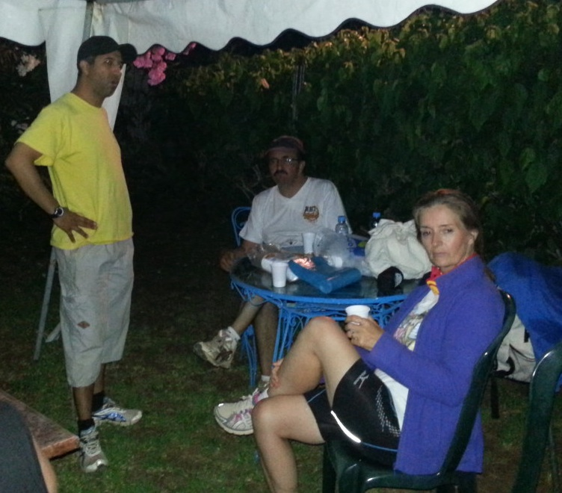
Led by Gyros & Tadpole, Wankers seemed enjoying the walkway in Hilton’s Wood that was not even hard for Bob The Builder's familly! So, as far as I can guess from their faces when they were back, We could ask what did they do to please themselves this much!?? But of course in Ramadan we keep such sense of curiosity to ourselves…
5 mn and then
The Ftour. Ouf!

As Soon Athan and the Cannon blast heard, Mother Hen rushed to make sure the show starts properly… And it did?!! In less time than saying it, (time is very relative in Ramadan) a table was ready in a side of the garden, and to complete the Fast Breaking ceremony, CHEF/DJ Gyros put the utmost Ramadanian atmosphere, andaloussi Music and some Arabian soothing melodies (Gyros' personal treasure) for all the benefit of our GM who chose to sit next to the hidden speakers behind the trees…
Do you
Want more?
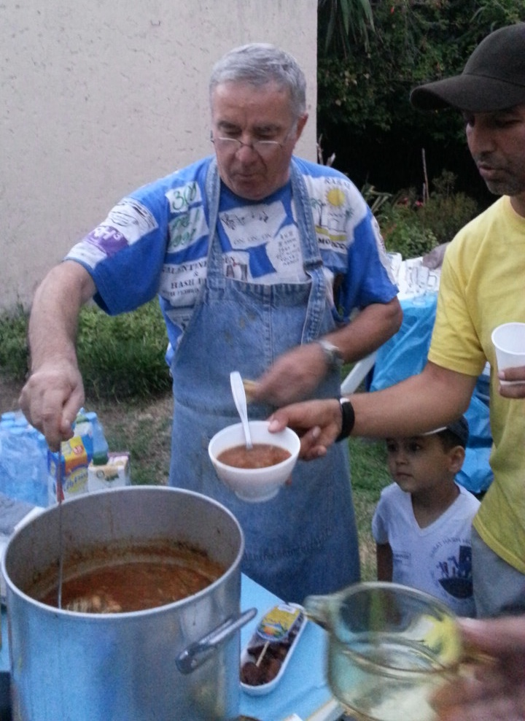
Well some of the fellow Hariettes & hashers did not notice this until they had their dose of water and a belly full of Harira! ON ON ! GYROS for the awesome home-made HaRrira (Was it the hunger? was it Gyros? No one can tell… LOL! ) but surely served with style (Yeah Gyros was dressed accordingly) and with a great sense of humor. Such an artist! BTW, I knew where all the flour went (in the Harira). It was supposed to go for setting the trail with !

I think everyone found a corner or a chair to enjoy a Hashy-Moroccan-Greek traditional ftoor?. Bodyguard, avoided interrupting happy hashers during their casual and surely meaningless talks, yelled finally to circle-up. At the menu, we had long term returnees Last Dancer, Scrooge and Tadpole and very short term ones as Horny Parker, T-Bread and Clean pants. Everyone managed to explain whatever the reason for not coming was, but we all know none could be a good reason. Hashers we are and to Saturday Hash we belong!! (Wow! scary statement here…?)
Yes! The flour went
Into the Harira

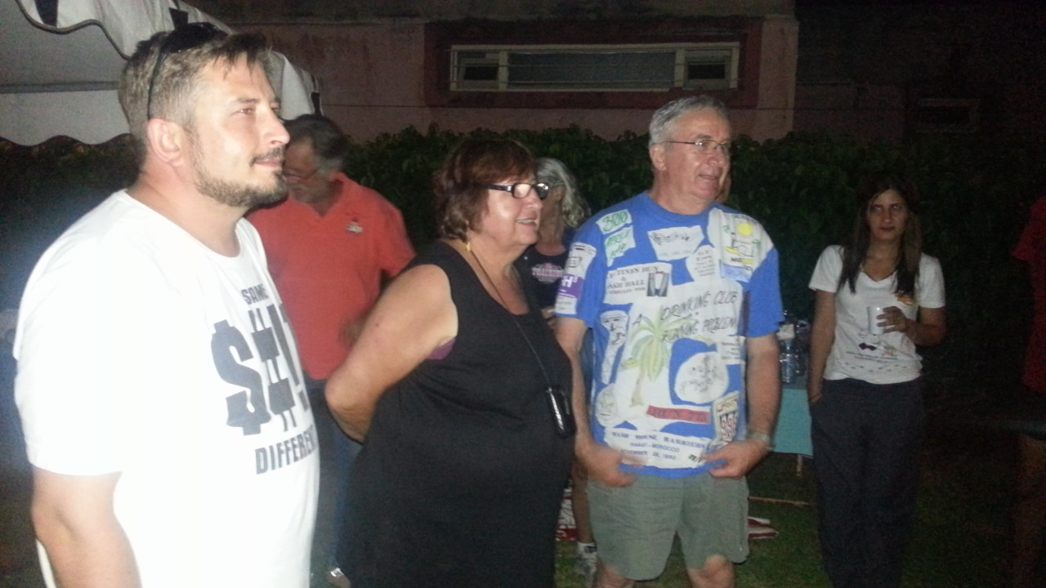
Many accusations were made, those I remember: Short cutters/long cutters had also a lesson to be taught from bodyguard: Never do such thing in front of GM/JM – MPFree & CP were the victims of this trial considering the effort engaged to follow the FRB. A funny surprise to Sex & The City was the GM accused her for lastweek’s hash trash! What can we add to our GM’s words?? “layster o safi” (translate: May the spirit of the hash have mercy upon us)

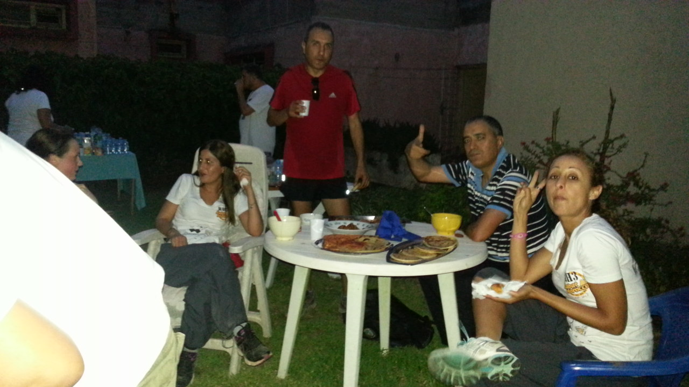
Anyway, in the meantime, some were busy exchanging ideas while the GM or the JM was doing the talking; of course Vagina Monologue had to do it again…Ooops! and again….until she no longer enjoy having orange juice in the circle, but she’s always in the mood of a show time!. “Sacrée VM!!”
ON ON !

The wrap up was done by VM, Clean pants and Laid-Back circled for the so-known “swing low”. Question?? How come for such many years, some of our fellow hasher still don’t recall all the gestures???

ON ON!
CLEAN PANTS
Decoration MPFree.

NEXT HASH #1460
VENUE: Caligula’s place
HARES: Caligula & Chef De Cuisine

