



Run # 20 July 2013, at Caligula and Chef de Cuisine’s

Hares : Chef de Cuisine - Sex and the City - Vagina Monologue

Once again, hashers conquered Our GM Caligual’s house, pool, garden and Kitchen, for they show up in big number on this hot and long fasting day, for the second “hashamadan”
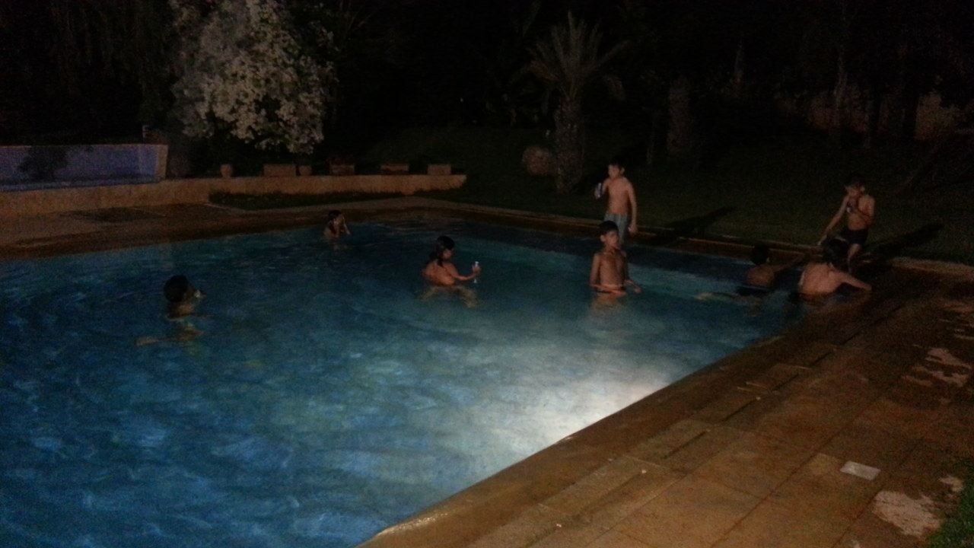
Big Thanks to Chef de Cuisine for allowing this, and for permitting the 10 or so kids to have a blast at the pool !! ( when tested later after the run by the grown up hashers, water was hot, I wonder what the kids had to do with this !! )
From around 17-30, hashers started pouring to the venue. By 18h30, they were more than 30 and a dozen of kids, among them, Pink Flamingo, Walky-talky, Café au lait, Humpty Dumty, Brilliantine, and the returnee / visitor Desert Orchid. Yet, no one seems to be keen on running or walking, since the prospect of a ‘ lazy laidback ’ by the pool looks more promising !
But we are hashers, so the hash and the trail thy shall honour !!
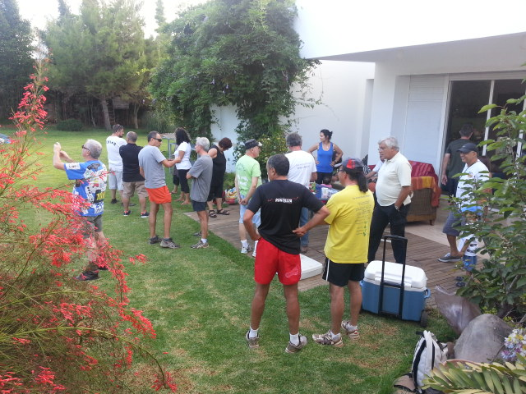
Bodyguard and GM unconvincingly called “circle up “ and hashers unconvincingly obeyed to listen to some not convincing explanations about the trail and about what to expect !
Runners and walkers out they went, right they turned and down the street fast runners disappeared !
Later on the trail, it was difficult to guess where the trail may or may not lead us; for the hares were, each in her own category, a bunch of non conventional ones! So T- Bread, Ratatouille, Just Leoné, Mpfree and Bodyguard (and Sex and the City keeping an eye behind) started running very fast toward what they rightly guessed will be the hares favourite spot, where we had many trails before, an empty spot with already booked and marked lawns, soon to host some of the most luxurious homes of Rabat !
There, runners could not but to notice that the hash marks had strange forms ! T-Bread enthusiastically shouted SET BY A CAR !! He even stopped and tried to analyse the angle and the speed of the “engine” that was currying the “ flour throwing machine” !
The first half of the run was long, fast and pleasant ! Front runners were still friendly and, once in a while, waited for the slow runners among them ! But at the second half and as if chased by bulls in a paddy field, ( or was it the prospect of a good iftar by the pool ? ) front runners charged toward the On In, ignoring the harriets who were running alone behind (Sex and the City, Just Leoné) . T-Bread and Ratatouille having left soon after Iftar, Sex and the City rightly charged Bodyguard for this sin !
Back at the On In, slowly walkers and wankers started showing up, after what seemed to have been a “ pleasant walk in the neighbourhood”.
Few had a dip in the hot water pool, while the rest took seats at the well garnished and presented Iftar tables ! Load of food : harira, baghrir, msemmen, harcha, jus, vinoiseries, café, milk .. and few beers !!
After the feast, it was difficult to start a circle ! Chef de Cuisine and Caligula even suggested to escape it, SHAME !
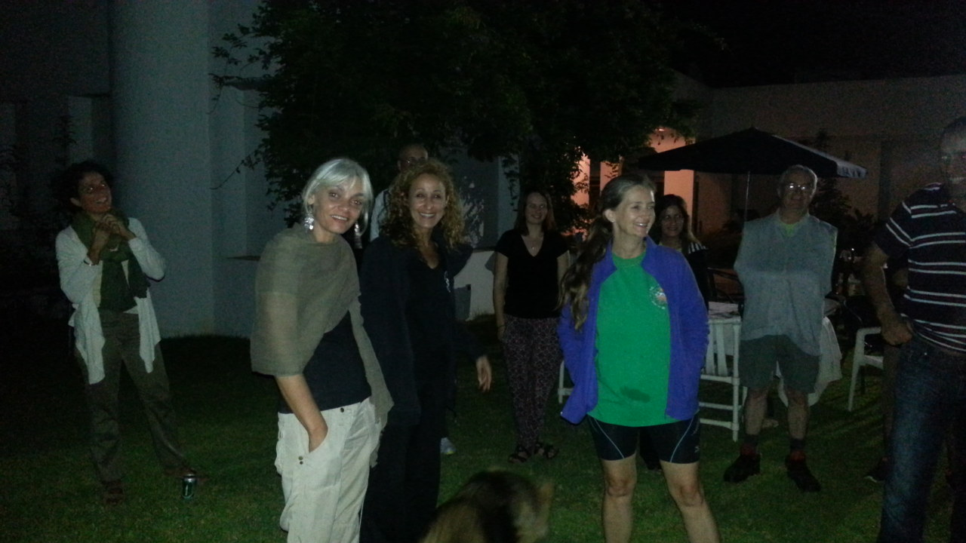
Hares were graciously rewarded for the “ effort” as the were allowed to sit in the middle of the circle ! When asked what they thought of this run/walk, hashers followed unanimously said “ beautiful “ ! Who said eating after abstention does not soften the soul ?!!
Hot Rocks called and punished the returnees and the new bees !
welcome to the French one, who was born in Kenitra and came with Tedpole and Gyros and seems to have some drinking and hashing abilities !
Blablabal continued for a little while, until food was properly digested, beers water and juice consumed ! MPfree, Quick Fix, Horny Parker, performed a ‘ flirting “ version of Swing low then we all said OnOn.
Later on talk, there was a very animated discussion between Gyros, Laid Back and Matador ! it was all about how the city Kenitra used to be ! ! Go guess what this has to do with what !!

That’s all folks !!

Bodyguard

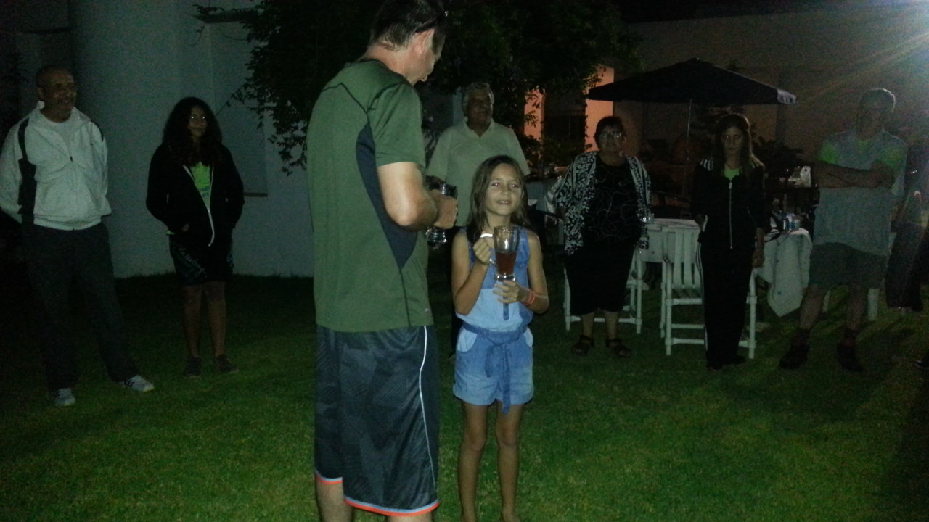

Next run : 27 July 2013 at 18h00 ( running at 18h30) at
Venue : Ratatouille’s place at Harhoura

Interhash in Brussels : http://www.interhash2014.com/....

