



Run #1461 27 July 2013, at Ratatouille’s place

Hares : Ratatouille and Zaalouk

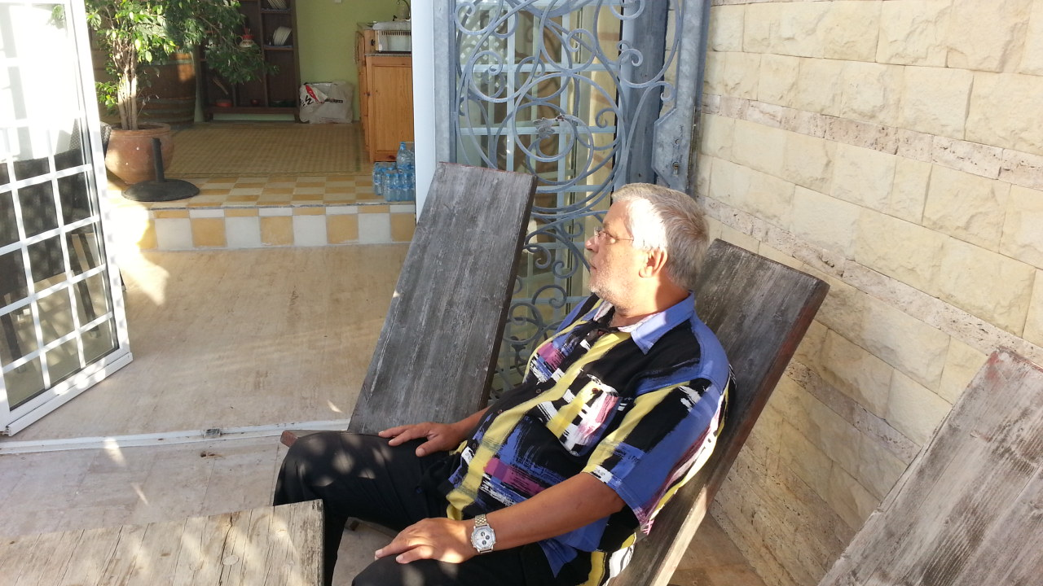
Unlike the previous week, few hashers showed up for this run ! Though, every thing was there for a good hash and Ratatouille spared no effort to make impress : a long enough trail, a well set table, plenty of 5 stars food, clean table and chairs and a mowed lawn ! the only thing that didn't fit in this not soo hashy picture, was Laidback with his 5 days beard and fasting bad mood and anger !
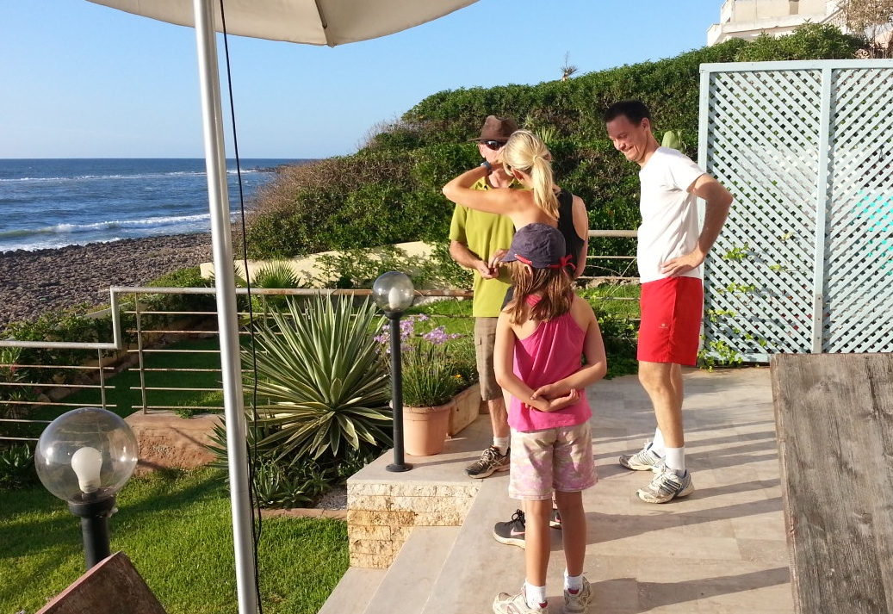
But first thing first : since your standing by scribe lives not so far from the venue, he went a bit late ( as if he is always on time), but to his surprise, he was the 4th one to arrive, and not many came after him ! there was the usual suspect MPfree with his flashy phone/ cum/ com/coming/ camera in hand ! there was no beauty to take photo of, so he decided to take one of bodyguard ! I never see all the photos he takes at the hash, and i wonder what and when those photos will be used for! However, just go to the website to see them.
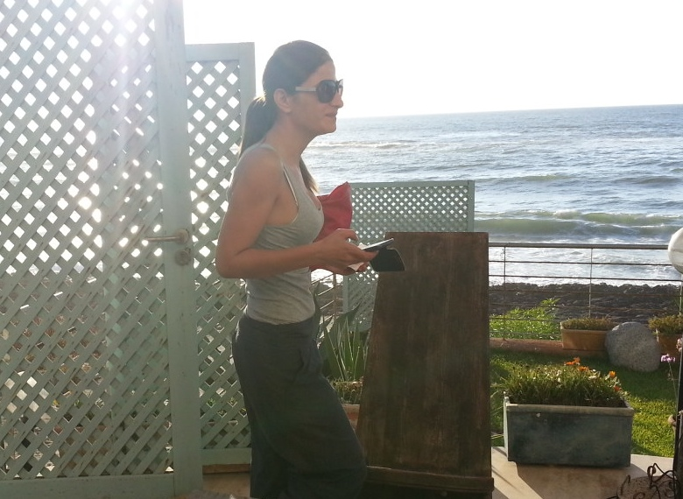
There we also just Karen and her lovely daughter (punish me next time for forgetting her name ) ! She is from england and had " good" intention of joining the hash while ago ! its better late then never lady ! ahh and she is a true runner, Tbread, Compost Sex and the city .. be ready, u will have a run for your ...is it money ? ! her lovely daughter of 9 or then years old will be very well admitted at our club by our little devils ( Ah Yeah and Caligula's , Walky talky, 9-11, ..) Last one to show up was horny parker ( I hear you whispering : whats new ) ! after convincing Laidback to stand up ( he was sitting on those tickwood chairs, that look like coming strait from a stone-age movie ) we decided to hit the road !
Since there was a trail, we split in two groups ( 3 in each ) , runners and walkers segregation obliges ! we did have a quite long run at the usual trail set by Ratatouille ! you know, from home to the forest to the road, to the big house/ place ( this time there was no beer stop at this point ) ! When Zaalook thought he did a good job running with the two runners, Bodyguard suggested to have an other bit of live run ! just karen seemed delighted with the idea, but Zaalook just put a little smile to hide his disapproval ( after all, he is a gentleman and no way he will show otherwise in front of just Karen !
After a fast and long live trail, back home we reached, wet and thirsty we were !
Walkers ? yes, Horny parker, Laidback and the little just came a bit after the runners, exhausted and very hungry for they had few bags full of " some eating stuff " !
Ratatouille ? as good host ( or was he a hostage to this hash ?), he stayed back to arrange the iftar table ! Since he was expecting around 30, there was plenty of food and drinks, elegantly displayed on a 6 chairs clothed table ! ( is this a hash ?)
The sun, dressed in its beautiful red/purple dress, started its evening dip into the ocean ! MPfree , the hash flash, as always, was not there when he was needed !
After eating, drinking and smoking ( thats Laidback and Horny parker ), we were too lazy to call the circle on !
And, unlike last week, we remained lazy for we skipped the circle and called it an other day !

Thats all folks !
Bodyguard

Next run : TBA

